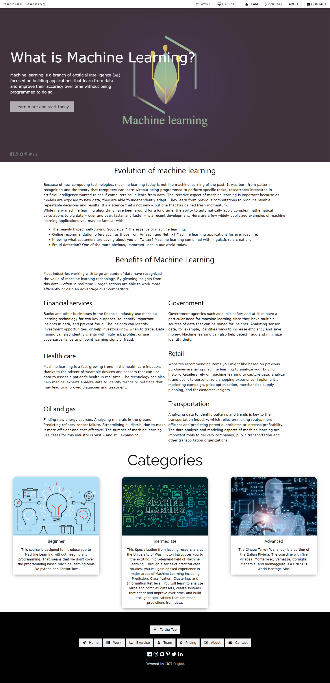**Website Pages**

**Home**

**Work**

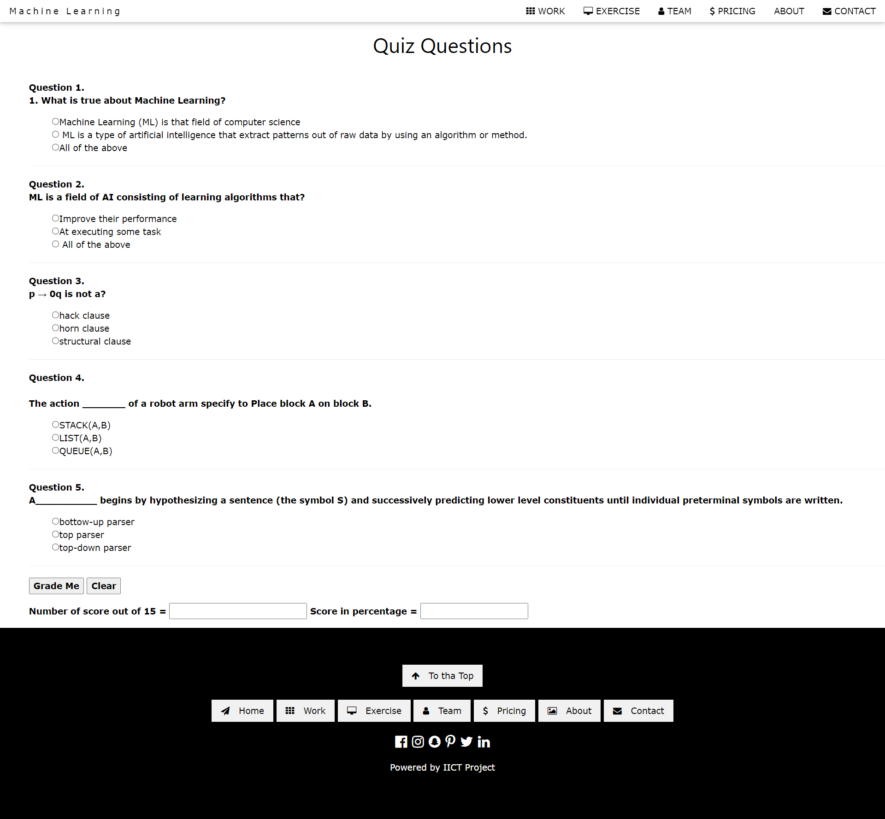**Exercise**

**Team**

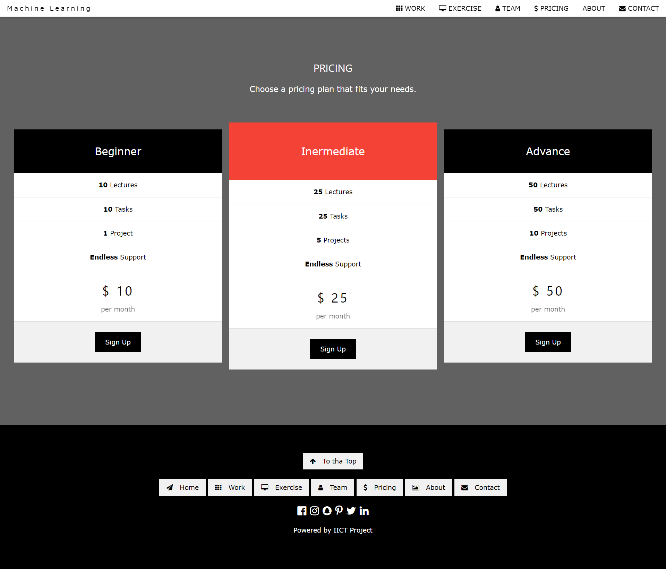**Pricing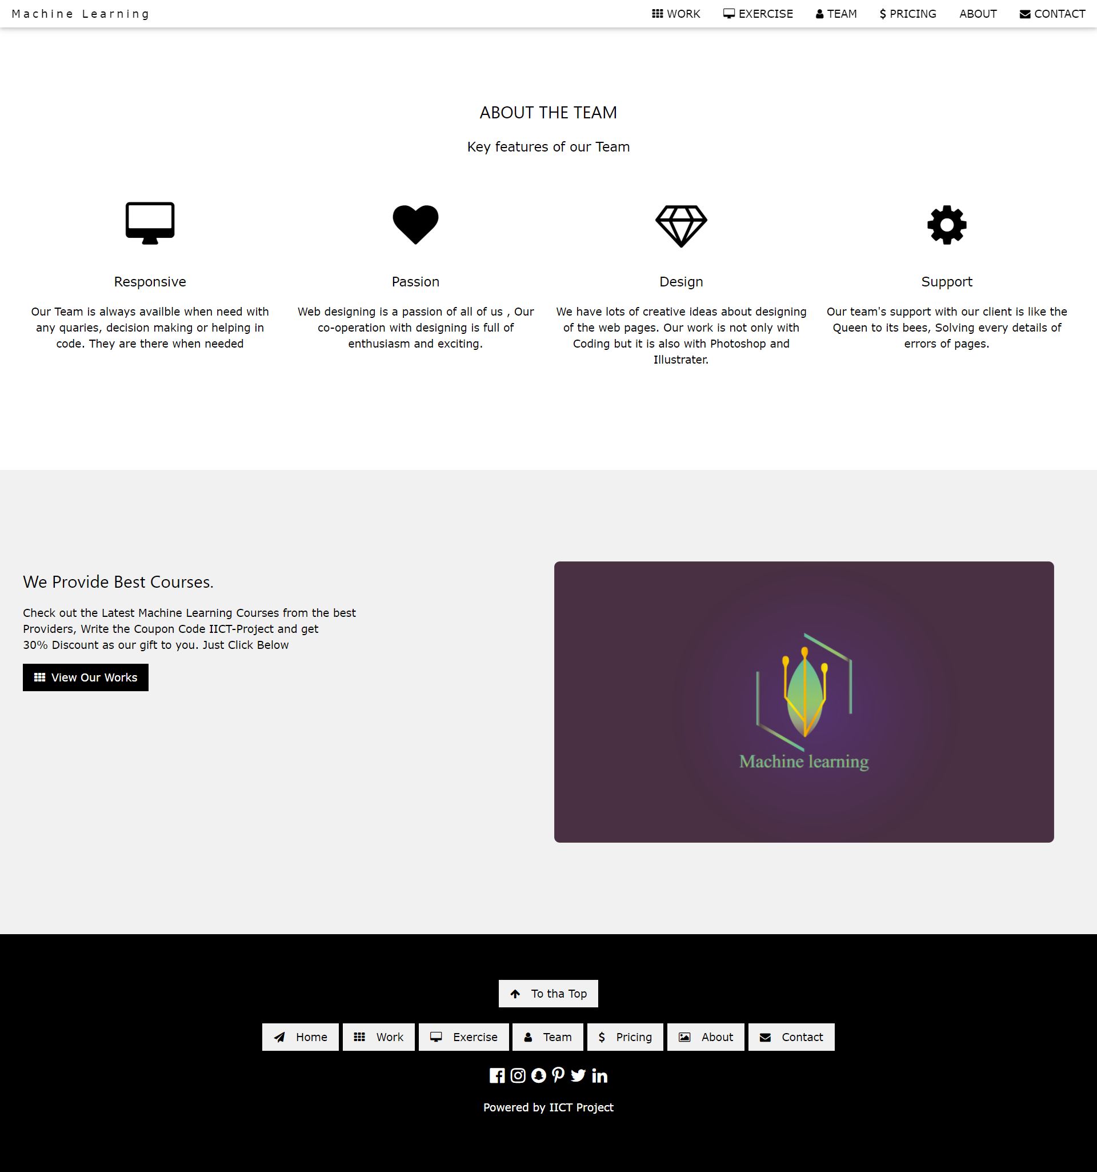About**

**Contact**

**About our Project Topic**

**Machine Learning**

Machine learning is a method of data analysis that automates analytical model building. It is a branch of [artificial intelligence](https://www.sas.com/en_us/insights/analytics/what-is-artificial-intelligence.html) based on the idea that systems can learn from data, identify patterns and make decisions with minimal human intervention.

Evolution of machine learning

Because of new computing technologies, machine learning today is not like machine learning of the past. It was born from pattern recognition and the theory that computers can learn without being programmed to perform specific tasks; researchers interested in artificial intelligence wanted to see if computers could learn from data. The iterative aspect of machine learning is important because as models are exposed to new data, they are able to independently adapt. They learn from previous computations to produce reliable, repeatable decisions and results. It’s a science that’s not new – but one that has gained fresh momentum.

While many machine learning algorithms have been around for a long time, the ability to automatically apply complex mathematical calculations to [big data](https://www.sas.com/en_us/insights/big-data/what-is-big-data.html) – over and over, faster and faster – is a recent development. Here are a few widely publicized examples of machine learning applications you may be familiar with:

* The heavily hyped, self-driving Google car? The essence of machine learning.
* Online recommendation offers such as those from Amazon and Netflix? Machine learning applications for everyday life.
* Knowing what customers are saying about you on Twitter? Machine learning combined with linguistic rule creation.
* Fraud detection? One of the more obvious, important uses in our world today.

## Why is machine learning important?

Resurging interest in machine learning is due to the same factors that have made [data mining](https://www.sas.com/en_us/insights/analytics/data-mining.html) and Bayesian analysis more popular than ever. Things like growing volumes and varieties of available data, computational processing that is cheaper and more powerful, and affordable data storage.

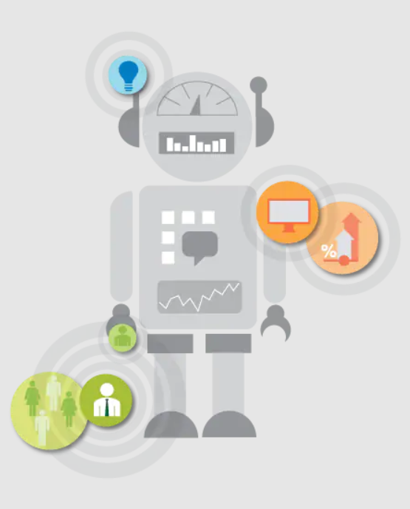All of these things mean it's possible to quickly and automatically produce models that can analyze bigger, more complex data and deliver faster, more accurate results – even on a very large scale. And by building precise models, an organization has a better chance of identifying profitable opportunities – or avoiding unknown risks.

### **What's required to create good machine learning systems?**

* Data preparation capabilities.
* Algorithms – basic and advanced.
* Automation and iterative processes.
* Scalability.
* Ensemble modeling.

## What are some popular machine learning methods?

Two of the most widely adopted machine learning methods are **supervised learning** and **unsupervised learning** – but there are also other methods of machine learning. Here's an overview of the most popular types.

**Supervised learning**algorithms are trained using labelled examples, such as an input where the desired output is known. For example, a piece of equipment could have data points labelled either “F” (failed) or “R” (runs). The learning algorithm receives a set of inputs along with the corresponding correct outputs, and the algorithm learns by comparing its actual output with correct outputs to find errors. It then modifies the model accordingly. Through methods like classification, regression, prediction and gradient boosting, supervised learning uses patterns to predict the values of the label on additional unlabelled data. Supervised learning is commonly used in applications where historical data predicts likely future events. For example, it can anticipate when credit card transactions are likely to be fraudulent or which insurance customer is likely to file a claim.

**Unsupervised learning**is used against data that has no historical labels. The system is not told the "right answer." The algorithm must figure out what is being shown. The goal is to explore the data and find some structure within. Unsupervised learning works well on transactional data. For example, it can identify segments of customers with similar attributes who can then be treated similarly in marketing campaigns. Or it can find the main attributes that separate customer segments from each other. Popular techniques include self-organizing maps, nearest-neighbor mapping, k-means clustering and singular value decomposition. These algorithms are also used to segment text topics, recommend items and identify data outliers.

**Semi supervised learning**is used for the same applications as supervised learning. But it uses both labelled and unlabelled data for training – typically a small amount of labelled data with a large amount of unlabelled data (because unlabelled data is less expensive and takes less effort to acquire). This type of learning can be used with methods such as classification, regression and prediction. Semi supervised learning is useful when the cost associated with labelling is too high to allow for a fully labelled training process. Early examples of this include identifying a person's face on a web cam.

**Reinforcement learning** is often used for robotics, gaming and navigation. With reinforcement learning, the algorithm discovers through trial and error which actions yield the greatest rewards. This type of learning has three primary components: the agent (the learner or decision maker), the environment (everything the agent interacts with) and actions (what the agent can do). The objective is for the agent to choose actions that maximize the expected reward over a given amount of time. The agent will reach the goal much faster by following a good policy. So the goal in reinforcement learning is to learn the best policy.

### **How it works**

#### **To get the most value from machine learning, you have to know how to pair the best algorithms with the right tools and processes. SAS combines rich, sophisticated heritage in statistics and data mining with new architectural advances to ensure your models run as fast as possible – even in huge enterprise environments.**

**Algorithms**: SAS graphical user interfaces help you build machine learning models and implement an iterative machine learning process. You don't have to be an advanced statistician. Our comprehensive selection of machine learning algorithms can help you quickly get value from your big data and are included in many SAS products. SAS machine learning algorithms include:

|  |
| --- |
| [**Neural networks**](https://www.sas.com/en_us/insights/analytics/neural-networks.html) |
| **Decision trees** |
| **Random forests** |
| **Associations and sequence discovery** |
| **Gradient boosting and bagging** |
| **Support vector machines** |
| **Nearest-neighbor mapping** |
| **k-means clustering** |
| **Self-organizing maps** |

|  |
| --- |
| **Local search optimization techniques (e.g., genetic algorithms)** |
| **Expectation maximization** |
| **Multivariate adaptive regression splines** |
| **Bayesian networks** |
| **Kernel density estimation** |
| **Principal component analysis** |
| **Singular value decomposition** |
| **Gaussian mixture models** |
| **Sequential covering rule building** |

**Tools and Processes**: As we know by now, it’s not just the algorithms. Ultimately, the secret to getting the most value from your big data lies in pairing the best algorithms for the task at hand with:

|  |
| --- |
| **Comprehensive data quality and management** |
| **GUIs for building models and process flows** |
| **Interactive data exploration and visualization of model results** |
| **Comparisons of different machine learning models to quickly identify the best one** |

|  |
| --- |
| **Automated ensemble model evaluation to identify the best performers** |
| **Easy model deployment so you can get repeatable, reliable results quickly** |
| **An integrated, end-to-end platform for the automation of the data-to-decision process** |